Title | Interactive Scatter Plot with Bokeh
Problem Statement | Create an interactive scatter plot showing the relationship between petal length and petal width from the Iris dataset using Bokeh.
Objectives | • To understand interactive scatter plot visualization using Bokeh.  • To load and organize the Iris dataset using Pandas and scikit-learn.  • To visualize the relationship between petal length and petal width.  • To differentiate Iris species using separate colors and an interactive legend.  • To use Bokeh hover, zoom, pan, reset and save tools for interactive analysis.
Dataset  URL Link /  File | Dataset: Built-in Iris dataset loaded using sklearn.datasets.load_iris(). Selected attributes: Petal Length (cm), Petal Width (cm), and Species.
  Species | Samples
  setosa | 50
  versicolor | 50
  virginica | 50
Functions  Details | Sl. No. | Function | Package | Description of function
Functions  Details | 1 | load_iris() | sklearn | Loads the built-in Iris dataset.
Functions  Details | 2 | rename() | Pandas | Renames dataset columns for clearer labels.
Functions  Details | 3 | map() | Pandas | Maps numeric target values to species names.
Functions  Details | 4 | DataFrame() | Pandas | Represents the selected Iris attributes in tabular form.
Functions  Details | 5 | ColumnDataSource() | Bokeh | Creates a Bokeh-friendly data source.
Functions  Details | 6 | figure() | Bokeh | Creates the interactive plotting canvas.
Functions  Details | 7 | scatter() | Bokeh | Plots petal length against petal width.
Functions  Details | 8 | HoverTool() | Bokeh | Displays species and measurements on hover.
Functions  Details | 9 | add_tools() | Bokeh | Adds the hover tool to the Bokeh figure.
Functions  Details | 10 | value_counts() | Pandas | Counts the records belonging to each Iris species.
Functions  Details | 11 | corr() | Pandas | Calculates correlation between petal length and width.
Functions  Details | 12 | output_file()/save() | Bokeh | Saves the interactive visualization as an HTML file.
Steps/  Process/  Procedure/  Algorithm/  Flowchart/  Model | 1. Import Pandas, the Iris dataset utility, and required Bokeh modules.  2. Load the Iris dataset and rename the petal measurement columns for clarity.  3. Convert numeric target values into the species names setosa, versicolor and virginica.  4. Create a DataFrame containing Petal Length, Petal Width and Species.  5. Display sample records, dataset shape, species counts and correlation for verification.  6. Create a Bokeh figure with interactive pan, zoom, reset and save tools.  7. Plot one scatter series for each Iris species using a ColumnDataSource.  8. Add HoverTool so that species and measurements appear when the pointer is placed over a point.  9. Enable an interactive legend so species can be hidden or displayed.  10. Save the interactive Bokeh chart as an HTML file and verify successful execution.  Flow: START -> Load Iris Dataset -> Prepare DataFrame -> ColumnDataSource -> Bokeh Figure -> Scatter Plot -> Hover/Legend -> Save HTML -> STOP
Program | import pandas as pd  from sklearn.datasets import load_iris  from bokeh.plotting import figure, output_file, save  from bokeh.models import ColumnDataSource, HoverTool  from bokeh.palettes import Category10  # Load the Iris dataset  iris = load_iris(as_frame=True)  df = iris.frame.rename(columns={  "petal length (cm)": "Petal Length (cm)",  "petal width (cm)": "Petal Width (cm)"  })  df["Species"] = df["target"].map(dict(enumerate(iris.target_names)))  df = df[["Petal Length (cm)", "Petal Width (cm)", "Species"]]  print(df.head(10))  print("Dataset Shape:", df.shape)  print("Species Counts:")  print(df["Species"].value_counts())  correlation = df["Petal Length (cm)"].corr(df["Petal Width (cm)"])  print("Correlation:", round(correlation, 3))  # Create the interactive Bokeh figure  p = figure(  title="Interactive Scatter Plot: Iris Petal Length vs Petal Width",  x_axis_label="Petal Length (cm)",  y_axis_label="Petal Width (cm)",  width=900,  height=520,  tools="pan,wheel_zoom,box_zoom,reset,save"  )  colors = Category10[3]  for color, species in zip(colors, iris.target_names):  subset = df[df["Species"] == species]  source = ColumnDataSource(subset)  p.scatter(  x="Petal Length (cm)",  y="Petal Width (cm)",  source=source,  size=9,  color=color,  alpha=0.75,  legend_label=species  )  hover = HoverTool(tooltips=[  ("Species", "@Species"),  ("Petal Length", "@{Petal Length (cm)}{0.0} cm"),  ("Petal Width", "@{Petal Width (cm)}{0.0} cm")  ])  p.add_tools(hover)  p.legend.title = "Species"  p.legend.location = "top_left"  p.legend.click_policy = "hide"  output_file("program13_iris_scatter.html")  save(p)  print("Interactive scatter plot saved successfully.")
Output Snapshots  With  Explanation/  Observations | The following outputs were generated by executing the complete Program 13 code. The static chart image represents the interactive Bokeh visualization; the HTML file retains hover, zoom, pan and reset functionality.  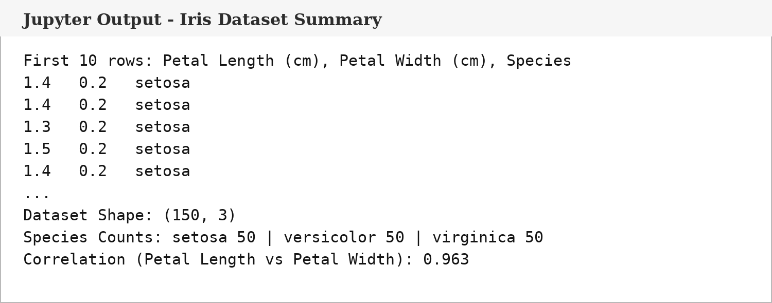  Fig. 1.1: Iris Dataset and Correlation Summary  The output verifies that 150 Iris samples were loaded, with 50 records for each species. The petal length-petal width correlation is approximately 0.963, indicating a strong positive relationship.  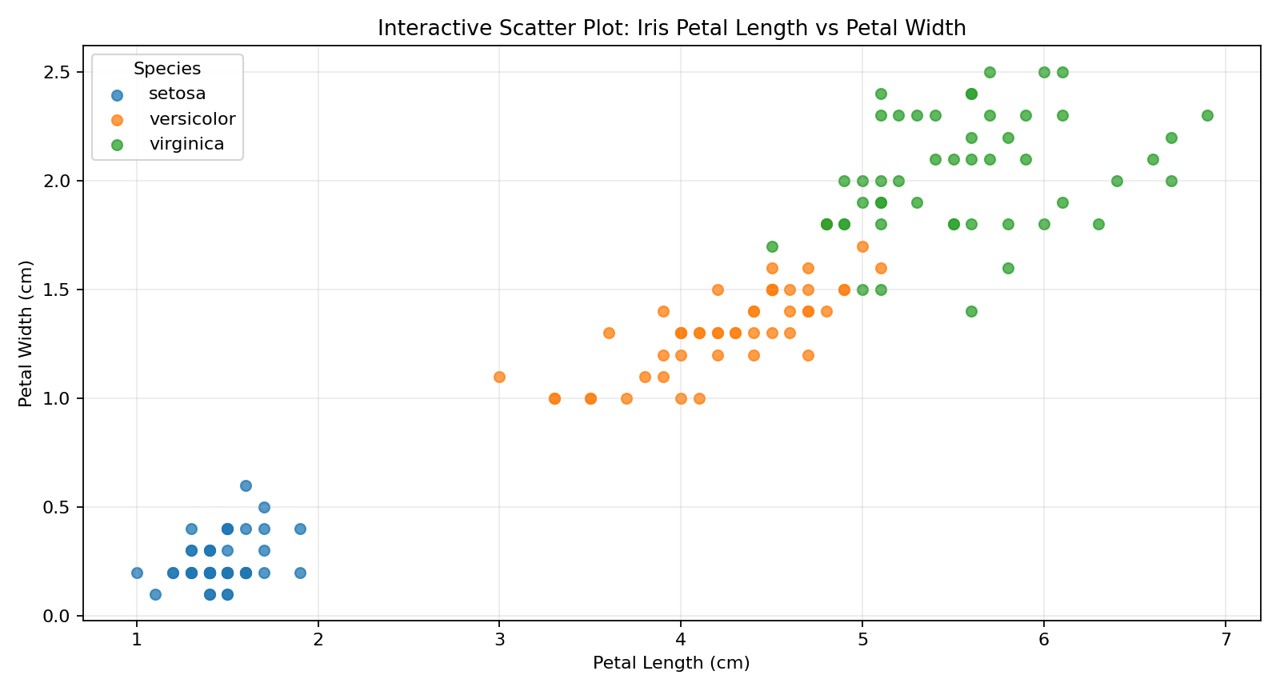  Fig. 1.2: Interactive Scatter Plot Output  The scatter plot shows three clearly distinguishable Iris species. Setosa forms a compact cluster at lower petal measurements, while versicolor and virginica occupy progressively larger petal-length and petal-width ranges.  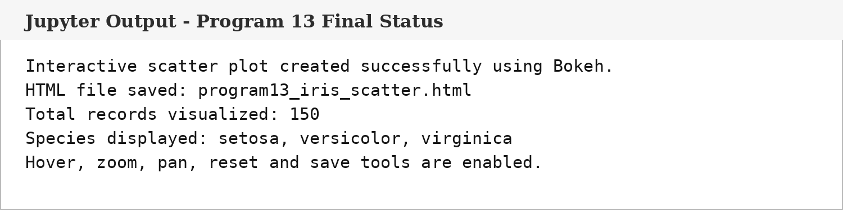  Fig. 1.3: Program 13 Execution and HTML Save Confirmation  The final execution confirms successful generation of the interactive Bokeh scatter plot and its HTML output. Hover, zoom, pan, reset and save tools are available in the saved interactive file.
Conclusions | The experiment was completed successfully using Pandas, scikit-learn and Bokeh. The Iris dataset was loaded and organized into a DataFrame containing petal length, petal width and species. The interactive scatter plot clearly demonstrated a strong positive relationship between petal length and petal width and visually separated the three Iris species. Bokeh interaction tools further enabled hovering, zooming, panning and legend-based filtering, making the visualization suitable for exploratory analysis.
References | 1. Bokeh Documentation: Open Link  2. Pandas Documentation: Open Link  3. scikit-learn Iris Dataset Documentation: Open Link  4. Python Program (GitHub link):  5. Class lecture link: Open Lecture Link

Title | Interactive Line Plot with Bokeh
Problem Statement | Create an interactive line plot showing the daily temperatures over a week using Bokeh.
Objectives | • To understand interactive line visualization using Bokeh.  • To organize daily temperature values in a Pandas DataFrame.  • To visualize day-wise temperature changes over one week.  • To identify the highest, lowest and average weekly temperature.  • To use hover, zoom, pan, reset and save tools for interactive time-series analysis.
Dataset  URL Link /  File | Dataset: Manually defined weekly temperature readings for seven consecutive days.
  Day | Temperature (°C)
  Monday | 29
  Tuesday | 31
  Wednesday | 30
  Thursday | 32
  Friday | 34
  Saturday | 33
  Sunday | 31
Functions  Details | Sl. No. | Function | Package | Description of function
Functions  Details | 1 | DataFrame() | Pandas | Creates a tabular dataset from the day and temperature values.
Functions  Details | 2 | ColumnDataSource() | Bokeh | Converts the DataFrame into a Bokeh data source.
Functions  Details | 3 | figure() | Bokeh | Creates the interactive Bokeh plotting canvas.
Functions  Details | 4 | line() | Bokeh | Draws the line connecting daily temperatures.
Functions  Details | 5 | scatter() | Bokeh | Adds visible markers for each day.
Functions  Details | 6 | HoverTool() | Bokeh | Displays day and temperature values on hover.
Functions  Details | 7 | add_tools() | Bokeh | Adds the hover tool to the figure.
Functions  Details | 8 | idxmax() | Pandas | Locates the day with the maximum temperature.
Functions  Details | 9 | idxmin() | Pandas | Locates the day with the minimum temperature.
Functions  Details | 10 | mean() | Pandas | Calculates the average weekly temperature.
Functions  Details | 11 | output_file() | Bokeh | Defines the HTML output filename.
Functions  Details | 12 | save() | Bokeh | Saves the interactive line plot as an HTML file.
Steps/  Process/  Procedure/  Algorithm/  Flowchart/  Model | 1. Import Pandas and the required Bokeh modules.  2. Define the seven days of the week and their corresponding temperature values.  3. Create a Pandas DataFrame and display it for verification.  4. Calculate the highest, lowest and average temperature values.  5. Convert the DataFrame into a Bokeh ColumnDataSource.  6. Create a Bokeh figure using the days as categorical X-axis values.  7. Plot the temperature trend using a line and add markers for each day.  8. Add HoverTool to display the exact day and temperature interactively.  9. Save the completed visualization as an HTML file and verify successful execution.  Flow: START -> Create Weekly Dataset -> DataFrame -> Temperature Statistics -> ColumnDataSource -> Bokeh Figure -> Line + Markers -> Hover -> Save HTML -> STOP
Program | import pandas as pd  from bokeh.plotting import figure, output_file, save  from bokeh.models import ColumnDataSource, HoverTool  # Weekly temperature dataset  days = ["Monday", "Tuesday", "Wednesday", "Thursday", "Friday", "Saturday", "Sunday"]  temperatures = [29, 31, 30, 32, 34, 33, 31]  df = pd.DataFrame({"Day": days, "Temperature (°C)": temperatures})  print(df)  highest_row = df.loc[df["Temperature (°C)"].idxmax()]  lowest_row = df.loc[df["Temperature (°C)"].idxmin()]  average_temp = df["Temperature (°C)"].mean()  print("Highest Temperature:", highest_row["Day"], "-", highest_row["Temperature (°C)"], "°C")  print("Lowest Temperature:", lowest_row["Day"], "-", lowest_row["Temperature (°C)"], "°C")  print("Average Temperature:", round(average_temp, 2), "°C")  source = ColumnDataSource(df)  p = figure(  x_range=days,  title="Interactive Line Plot: Daily Temperature Over a Week",  x_axis_label="Day",  y_axis_label="Temperature (°C)",  width=900,  height=520,  tools="pan,wheel_zoom,box_zoom,reset,save"  )  p.line(x="Day", y="Temperature (°C)", source=source, line_width=3)  p.scatter(x="Day", y="Temperature (°C)", source=source, size=10)  hover = HoverTool(tooltips=[  ("Day", "@Day"),  ("Temperature", "@{Temperature (°C)} °C")  ])  p.add_tools(hover)  p.xgrid.grid_line_color = None  output_file("program14_temperature_line.html")  save(p)  print("Interactive line plot saved successfully.")
Output Snapshots  With  Explanation/  Observations | The following outputs were generated from the completed Program 14. The chart image is a static view of the interactive Bokeh line plot, while the saved HTML output contains the full interactive tools.  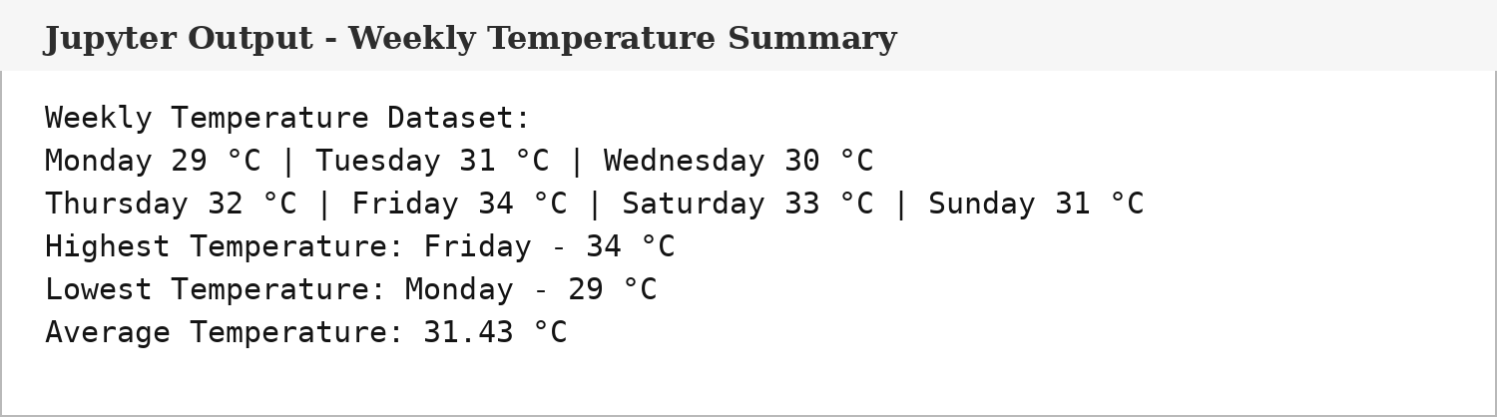  Fig. 2.1: Weekly Temperature Dataset and Statistical Summary  The dataset contains seven daily readings. Friday records the highest temperature of 34 °C, Monday records the lowest temperature of 29 °C, and the weekly average is approximately 31.43 °C.  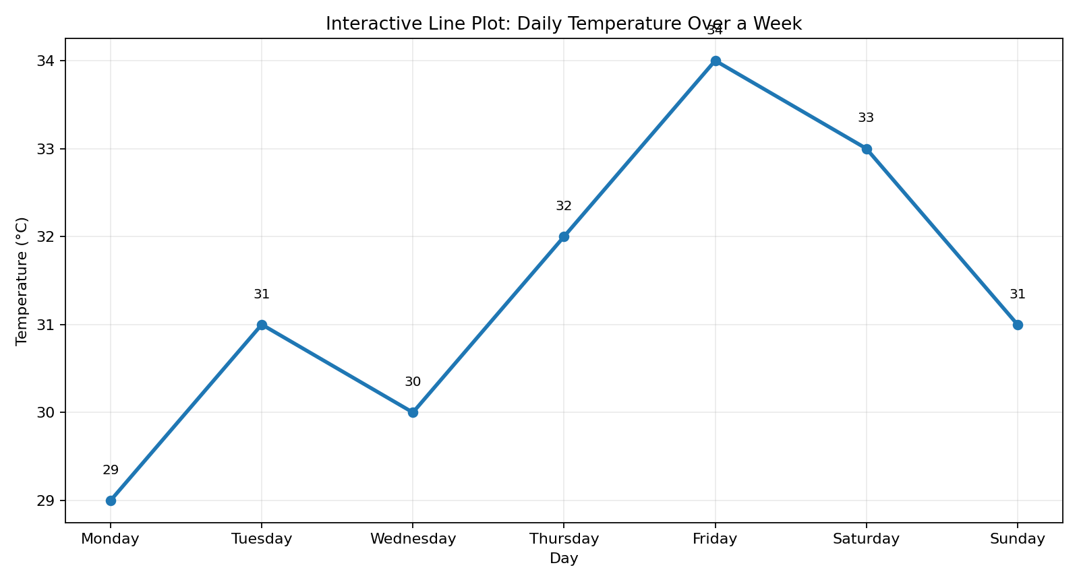  Fig. 2.2: Interactive Line Plot Output  The line plot shows the day-wise temperature variation across the week. The temperature rises overall from Monday to Friday, reaches its maximum on Friday, and decreases during the weekend.  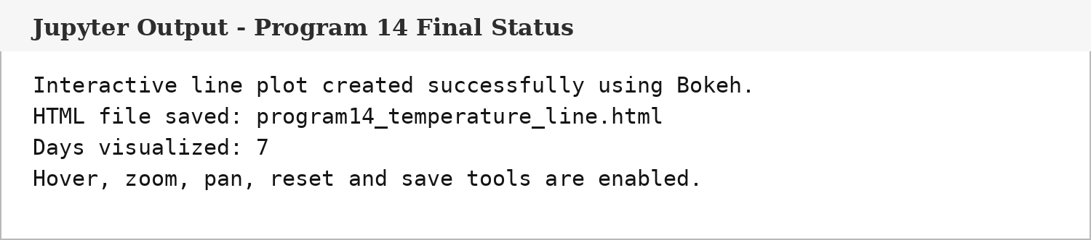  Fig. 2.3: Program 14 Execution and HTML Save Confirmation  The execution confirms successful creation and saving of the Bokeh line plot. The resulting HTML file supports hover, zoom, pan, reset and save interactions.
Conclusions | The exercise was completed successfully using Pandas and Bokeh. Daily temperature values for one week were organized in a DataFrame and visualized using an interactive line plot. Statistical analysis identified Friday as the hottest day, Monday as the coolest day, and the average weekly temperature as approximately 31.43 °C. The interactive Bokeh output makes the weekly trend easy to inspect using hover and navigation tools.
References | 1. Bokeh Documentation: Open Link  2. Pandas Documentation: Open Link  3. Python Program (GitHub link):  4. Class lecture link: Open Lecture Link

Title | Interactive Bar Chart with Bokeh
Problem Statement | Create an interactive bar chart showing the sales figures of different products using Bokeh.
Objectives | • To understand interactive categorical bar-chart visualization using Bokeh.  • To organize product-wise sales values in a Pandas DataFrame.  • To compare sales performance across different products.  • To calculate total, highest and average product sales.  • To use Bokeh hover, zoom, pan, reset and save tools for interactive analysis.
Dataset  URL Link /  File | Dataset: Manually defined product-wise sales values for six products.
  Product | Sales (Units)
  Laptop | 125
  Smartphone | 210
  Tablet | 95
  Headphones | 170
  Smartwatch | 140
  Camera | 80
Functions  Details | Sl. No. | Function | Package | Description of function
Functions  Details | 1 | DataFrame() | Pandas | Creates a structured product-sales DataFrame.
Functions  Details | 2 | ColumnDataSource() | Bokeh | Converts the DataFrame into a Bokeh data source.
Functions  Details | 3 | figure() | Bokeh | Creates the categorical plotting canvas.
Functions  Details | 4 | vbar() | Bokeh | Draws one vertical bar for each product.
Functions  Details | 5 | HoverTool() | Bokeh | Displays product and sales values on hover.
Functions  Details | 6 | add_tools() | Bokeh | Adds the hover tool to the figure.
Functions  Details | 7 | idxmax() | Pandas | Locates the product with the highest sales.
Functions  Details | 8 | max() | Pandas | Returns the highest sales value.
Functions  Details | 9 | sum() | Pandas | Calculates the total number of units sold.
Functions  Details | 10 | mean() | Pandas | Calculates the average sales per product.
Functions  Details | 11 | output_file() | Bokeh | Defines the interactive HTML output filename.
Functions  Details | 12 | save() | Bokeh | Saves the completed Bokeh bar chart as HTML.
Steps/  Process/  Procedure/  Algorithm/  Flowchart/  Model | 1. Import Pandas and the required Bokeh modules.  2. Define the product names and their corresponding sales figures.  3. Create and display a Pandas DataFrame for verification.  4. Calculate total sales, the highest-selling product and average sales.  5. Convert the DataFrame to a Bokeh ColumnDataSource.  6. Create a categorical Bokeh figure with product names on the X-axis.  7. Use vbar() to display the product-wise sales values.  8. Add HoverTool so exact sales values are visible interactively.  9. Save the completed interactive bar chart as an HTML file and verify successful execution.  Flow: START -> Create Product Dataset -> DataFrame -> Sales Statistics -> ColumnDataSource -> Bokeh Figure -> Vertical Bars -> Hover -> Save HTML -> STOP
Program | import pandas as pd  from bokeh.plotting import figure, output_file, save  from bokeh.models import ColumnDataSource, HoverTool  # Product sales dataset  products = ["Laptop", "Smartphone", "Tablet", "Headphones", "Smartwatch", "Camera"]  sales = [125, 210, 95, 170, 140, 80]  df = pd.DataFrame({"Product": products, "Sales (Units)": sales})  print(df)  highest_row = df.loc[df["Sales (Units)"].idxmax()]  total_sales = df["Sales (Units)"].sum()  average_sales = df["Sales (Units)"].mean()  print("Total Sales:", total_sales, "units")  print("Highest Sales:", highest_row["Product"], "-", highest_row["Sales (Units)"], "units")  print("Average Sales:", round(average_sales, 2), "units")  source = ColumnDataSource(df)  p = figure(  x_range=products,  title="Interactive Bar Chart: Product Sales",  x_axis_label="Product",  y_axis_label="Sales (Units)",  width=900,  height=520,  tools="pan,wheel_zoom,box_zoom,reset,save"  )  p.vbar(x="Product", top="Sales (Units)", source=source, width=0.65)  hover = HoverTool(tooltips=[  ("Product", "@Product"),  ("Sales", "@{Sales (Units)} units")  ])  p.add_tools(hover)  p.xgrid.grid_line_color = None  output_file("program15_product_sales_bar.html")  save(p)  print("Interactive bar chart saved successfully.")
Output Snapshots  With  Explanation/  Observations | The following outputs were generated by executing Program 15. The static chart image presents the product-wise sales comparison, while the generated Bokeh HTML file preserves the interactive functionality.  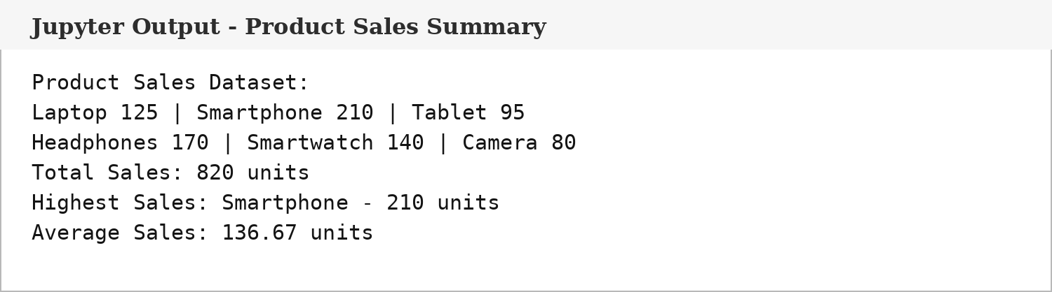  Fig. 3.1: Product Sales Dataset and Statistical Summary  The product dataset contains six sales values. Total sales are 820 units, Smartphone has the highest sales at 210 units, and average sales are approximately 136.67 units per product.  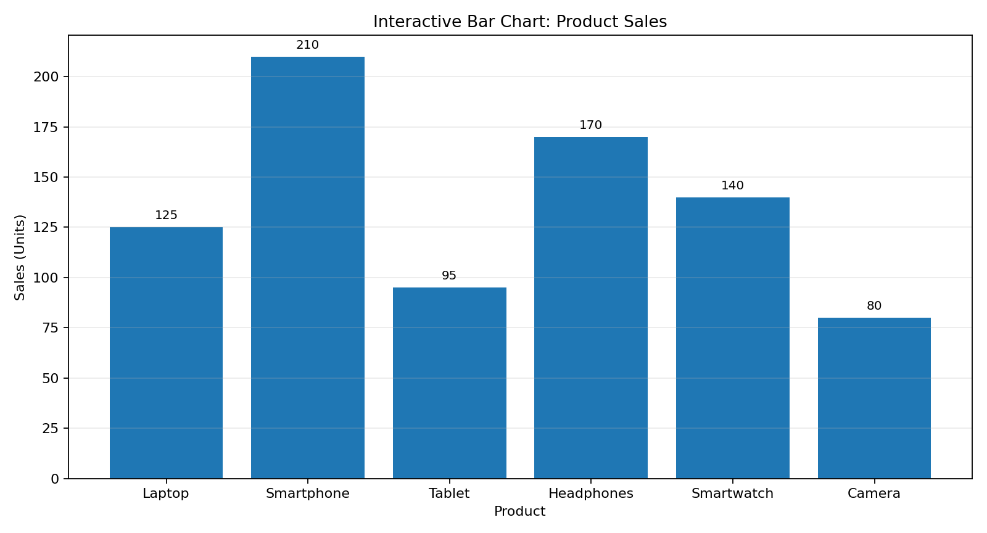  Fig. 3.2: Interactive Bar Chart Output  The bar chart compares sales across all six products. Smartphone is the highest-selling product, followed by Headphones, while Camera records the lowest sales.  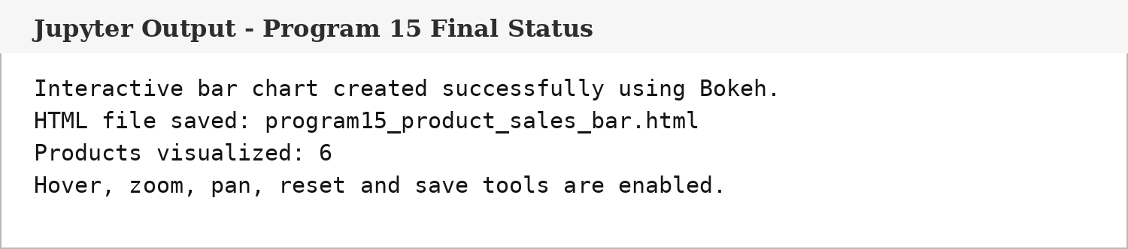  Fig. 3.3: Program 15 Execution and HTML Save Confirmation  The final execution confirms successful generation and saving of the Bokeh product-sales bar chart. The HTML output supports hover and navigation tools for interactive inspection.
Conclusions | The exercise was completed successfully using Pandas and Bokeh. Product sales data were organized in a DataFrame and visualized through an interactive vertical bar chart. Smartphone recorded the highest sales with 210 units, total sales were 820 units, and average sales were approximately 136.67 units. The visualization provides a clear product-wise comparison and the interactive Bokeh tools improve data exploration.
References | 1. Bokeh Documentation: Open Link  2. Pandas Documentation: Open Link  3. Python Program (GitHub link):  4. Class lecture link: Open Lecture Link

